**P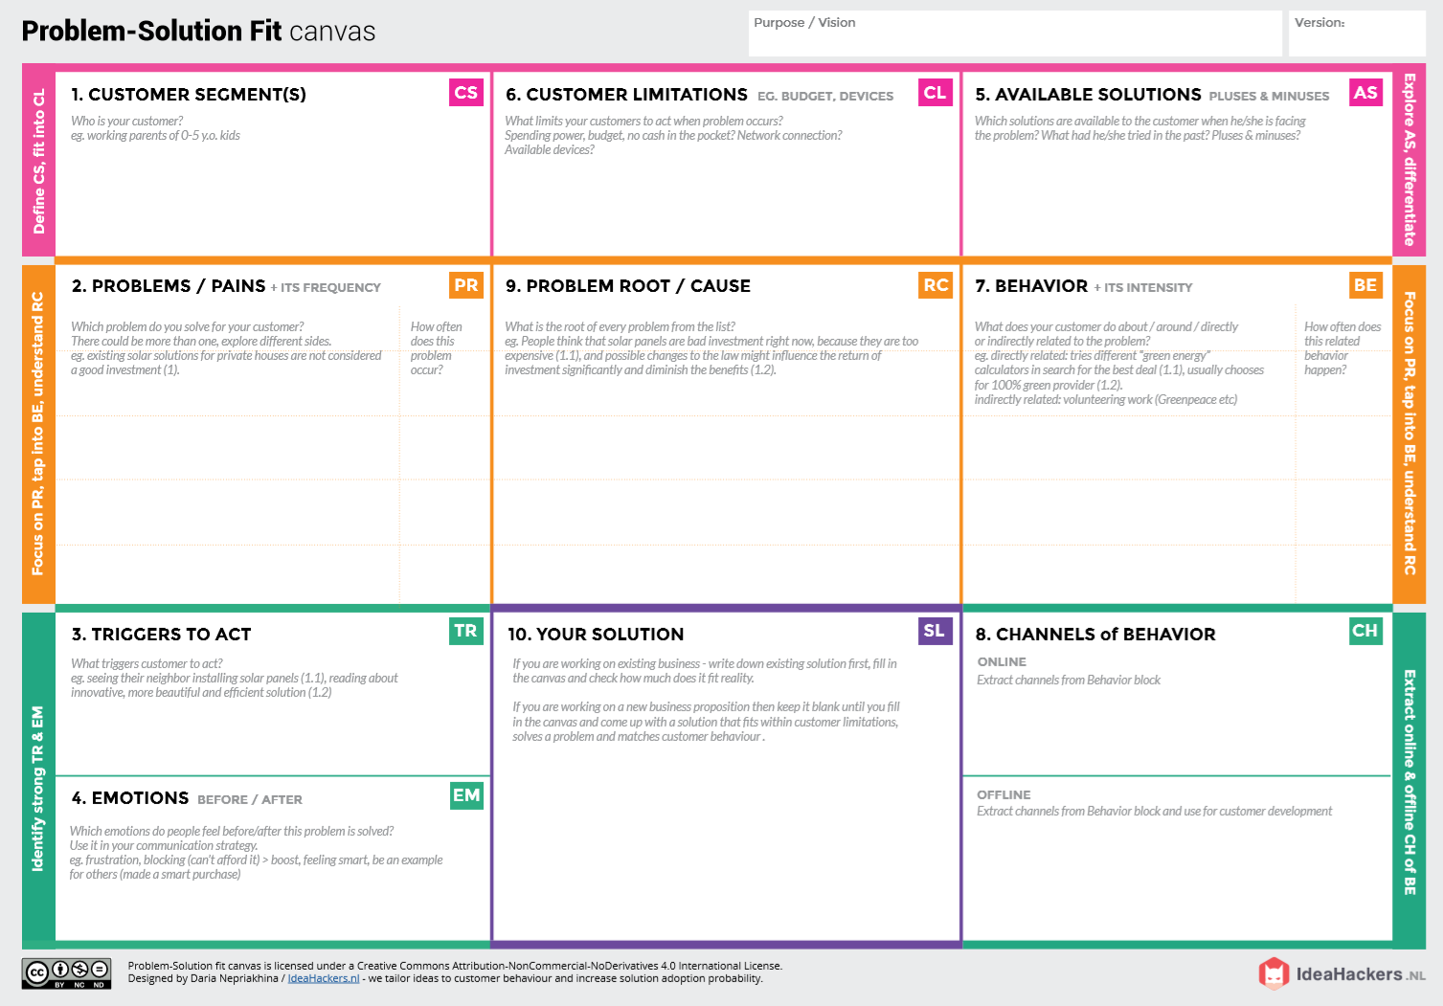roject** :IOt Based smart crop protection system for agriculture **Project Design Phase-1**:Solution fit

Farmer’s ! Who’s not near his field

* It’s difficult to monitor and control
* Ain’t known if the application doesn’t work properly.

Create opportunities to lift people out of poverty in developing nations. (Over 60% )

**BEFORE**: Finances, Heavy work overload and conflict in relationship.

**AFTER**: It will easier to make more yield in field

***“IoT based Smart crop protection system for agriculture” !!***

It help farmers grow more food on less land by protection crops from pests, diseases and weeds as well as raising productivity per hectare.

1)High adoption costs , security concerns. 2)Not aware of the implementation of IoT in agriculture.

1)If temperature ,PH level ,humidity & light intensity makes the serious cause for the environment.

2)Farmer affected by less productivity which will affect in their profit.

Monitor different parameters and mobile or web application make easily to farm the crop field .

**Direct related**: Tries to find a solution to prevent this problem

**Indirect related**: Located in rural where internet connectivity might not be strong enough to facilitate fast transmission speeds.

**ONLINE:** The Data send through application for the farmers to know about the farms.

**OFFLINE**: The control action is taken by the farmers to monitor the farms.

**Team ID**:PNT2022TMID22832